FDA Warning Labels LTE Template
Drafted August 15, 2019

FDA’s new proposed cigarette pack warning labels worth the wait

Dear Editor,

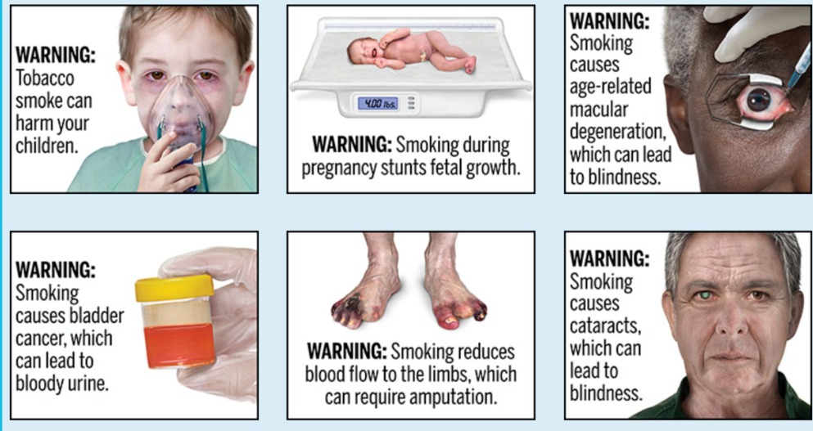
START BY SHARING THAT ON THURSDAY, AUGUST 15, THE FEDERAL DRUG ADMINISTRATION (FDA) UNVEILED 13 PROPOSED GRAPHIC CIGARETTE PACK WARNING LABELS. LET READERS KNOW THAT THE NEW WARNING LABELS FOCUS ON LESSER-KNOWN RISKS OF TOBACCO USE LIKE (INCLUDE EXAMPLES –FIND THE PROPOSED LABELS AT https://www.fda.gov/tobacco-products/labeling-and-warning-statements-tobacco-products/cigarette-health-warnings).

TALK ABOUT HOW THE WARNING LABELS ON CIGARETTES HAVEN’T BEEN UPDATED SINCE 1984. PROVIDE A LITTLE HISTORY BY SHARING THAT THE FDA PROPOSED NEW WARNING LABELS BACK IN 2011, BUT THEY WERE BLOCKED BY LAWSUITS FROM THE BIG TOBACCO COMPANIES. HOWEVER, A FEDERAL RULING DECIDED THAT THE FDA STILL HAD THE AUTHORITY TO UPDATE THE WARNING LABELS, AND IN 2016, EIGHT HEALTH GROUPS ACTUALLY SUED THE FDA FOR NOT MOVING FAST ENOUGH. THAT RESULTED IN A 2019 FEDERAL RULING GIVING THE FDA UNTIL AUGUST 15, 2019 TO ISSUE A PROPOSED RULE, AND UNTIL MARCH 15, 2020 TO FINALIZE THE RULE.

PERSONALIZE THE LETTER BY SHARING WHY YOU FEEL THIS IS IMPORTANT. POSSIBLY TALK ABOUT THE POWER OF SEEING TOBACCO IMAGERY WHEN YOU GO TO CONVENIENCE STORES, AND THE IMPORTANCE OF DISRUPTING THAT IMAGERY BY SHOWING THE REAL CONSEQUENCES OF TOBACCO USE. YOU CAN ALSO FIND EVIDENCE FOR THE STRATEGY HERE.

CLOSE BY URGING TOBACCO USERS TO CALL THE WISCONSIN TOBACCO QUIT LINE AT 1-800-QUIT NOW (784-8669) AND ENCOURAGING MEDICAID RECIPIENTS TO TALK TO THEIR DOCTOR ABOUT FREE HELP PROVIDED THROUGH THE MEDICAID CESSATION BENEFIT.

