Many communities have passed tobacco-free policies for outdoor spaces like parks, recreational facilities, beaches, and festivals. Clean air goes hand-in-hand with the intent of outdoor spaces, such as providing healthy opportunities for physical activity and connection with nature. Here are three major reasons to make outdoor spaces tobacco-free in [Community Name].

Cleaner Air
Secondhand smoke is still dangerous—even outside. In fact, studies show that outdoor exposure to secondhand smoke can reach levels on par with indoor exposure.^{,2} There’s no safe level of secondhand smoke.
Health issues linked to secondhand smoke include:³
- sudden infant death syndrome (SIDS)
- impaired lung function
- stroke
- heart disease
- lung cancer

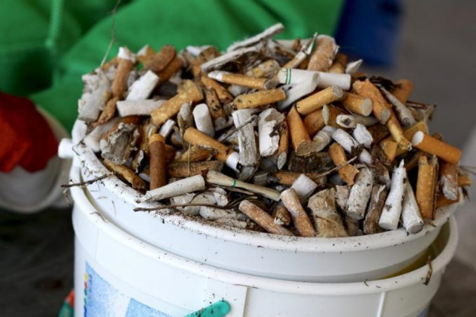
Less Litter
Cigarette butts are the most commonly discarded piece of waste worldwide.⁴ About 65% of smoked cigarettes are littered.⁵ Disposable e-cigarette pods, such as those used in JUUL products, also often end up as litter. This may leak both residual nicotine and heavy metals into the environment.⁶
Taxpayers and local authorities are left to pick up the bill for the cost of cleaning tobacco product waste.

Healthier Kids
Prohibiting all tobacco products, including e-cigarettes and smokeless tobacco, from outdoor spaces models healthier behavior for kids that encourages them to grow up tobacco-free.⁷ Tobacco-free parks also provide consistency for youth sports in [Community Name] by making expectations clear for teams, coaches, and fans.
“Quote – Include a quote here from a coalition member discussing why they support tobacco-free parks. Emphasize kids’ health, beauty of the community, etc.”

References

- Klepeis, N. et. al. (2007). “Real-time measurement of outdoor tobacco smoke particles.” Journal of the Air & Waste Management Association 57: 522-534. - Sureda, X., Fernández, E., López, M. J., & Nebot, M. (2013). “Secondhand Tobacco Smoke Exposure in Open and Semi-Open Settings: A Systematic Review.” Environmental Health Perspectives, 121(7), 766–773. - U.S. Department of Health and Human Services (2014). “The Health Consequences of Smoking—50 Years of Progress: A Report of the Surgeon General.” Atlanta: U.S. Department of Health and Human Services, Centers for Disease Control and Prevention, National Center for Chronic Disease Prevention and Health Promotion, Office on Smoking and Health. - Keep America Beautiful, Inc. (2017). “Cigarette Litter in America.” Retrieved from https://kab.org/wp-content/uploads/2016/03/2018_CLPP_Infographic.pdf - Keep America Beautiful, Inc. (2010). “Litter in America: Littering Behavior.” Retrieved from https://kab.org/wp-content/uploads/2019/11/LitterinAmerica_FactSheet_LitteringBehavior.pdf - Truth Initiative. (2019, April 23). “3 ways JUUL could harm the environment.” Retrieved from https://truthinitiative.org/research-resources/emerging-tobacco-products/3-ways-juul-harms-environment - U.S. Department of Health and Human Services (2012). “Preventing Tobacco Use Among Youth and Young Adults: A Report of the Surgeon General.” Retrieved from https://www.ncbi.nlm.nih.gov/books/NBK99237/pdf/Bookshelf_NBK99237.pdf

