National Oral, Head, and Neck Cancer Awareness Week (April 10-16)
Press Release Template
Drafted Tuesday, March 8, 2016

For Immediate Release: (INSERT DATE)
Contact: (INSERT NAME, PHONE NUMBER)

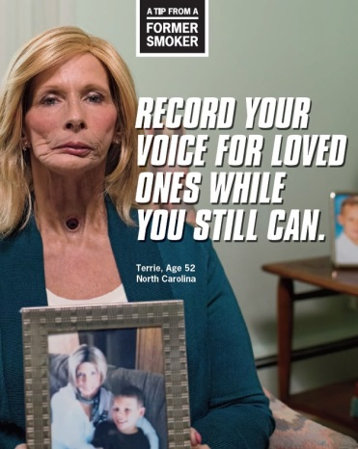
Reminder: Tobacco Use Causes Many Cancers, Including Oral, Head and Neck
(CITY, WI) – Local health advocates from (COALITION/NETWORK NAME) want people in (COUNTY/COMMUNITY) to know that the effects of tobacco use go beyond lung cancer. To support the group’s educational efforts, they’re using National Oral, Head, and Neck Cancer Awareness Week (April 10-16) to remind tobacco users that tobacco use also causes cancers of the mouth, nose, and throat.
“QUOTE FROM COALITION SPOKESPERSON OR PHYSICIAN ABOUT HOW IT’S IMPORTANT FOR COMMUNITY MEMBERS TO KNOW THE MANY WAYS TOBACCO HARMS ITS USERS. IF YOU CAN GET A DOCTOR, HAVE HE/SHE TALK ABOUT WHAT THESE CANCERS LOOK LIKE/HOW THEY ARE TREATED.”
Terrie Hall (above) suffered from throat cancer as a result of smoking and was featured in several national advertisements for CDC’s Tips from Former Smokers campaign. Hall died from her cancer in 2013 at the age of 53.

Besides causing these cancers, tobacco use and smoking can interfere with cancer treatment. In addition, cancer patients and survivors who continue to smoke have a higher risk of their cancer reoccurring or dying of other causes.
The good news is that individuals that smoke or use tobacco can cut their risk of these cancers by half within five years of quitting.
“QUOTE ABOUT HOW QUITTING SMOKING IS DIFFICULT, BUT WORTH IT. GIVE AN EXAMPLE OR TWO OF THE BENEFITS OF QUITTING FROM http://www.cancer.org/healthy/stayawayfromtobacco/guidetoquittingsmoking/guide-to-quitting-smoking-benefits,” SAID (NAME). “CONTINUE BY SAYING THERE ARE RESOURCES LIKE THE QUIT LINE TO HELP TOBACCO USERS BREAK THE ADDICTION.”
Tobacco users can receive free help by calling 1-800-QUIT NOW. For more on local tobacco prevention and control efforts, visit COALITION/NETWORK URL.
###

