Rebecca Ad Press Release Template
Drafted August 4, 2016

For Immediate Release: (INSERT DATE)
Contact: (INSERT NAME, PHONE NUMBER)

TV, print ads shine on spotlight connection between depression and tobacco use

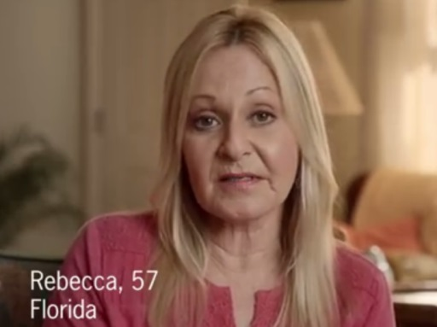
(CITY, WI) -- Like many individuals diagnosed with depression, Rebecca looked for ways to cope. She thought cigarettes would help, but as she explains in a new ad running this September in Wisconsin, they often just made things worse.

As she tells it, she would smoke to ease her depression, and then would try to quit. From there, she’d end up feeling more depressed when she wasn’t successful in giving up smoking. “That was a vicious, vicious cycle,” she says of her struggle. Ultimately, Rebecca was able to beat her addiction, as she details in the ad.

The combination of tobacco use and behavioral health (mental health or substance use disorders) is sadly all too common both in the U.S. and here in Wisconsin. According to the Centers for Disease Control and Prevention (CDC), nearly a third of all cigarettes are smoked by adults with a mental illness. In Wisconsin, individuals ever diagnosed with depression are nearly twice as likely as the general population to smoke cigarettes.

Rebecca’s ad, part of the CDC’s “Tips from Former Smokers” campaign, is scheduled to run in newspapers and on TV in the Green Bay, Milwaukee, and Madison markets during the week of September 5. The ads are timed to coincide with National Recovery Month, which seeks to build awareness and understanding of mental health and substance use disorders and celebrate the people, like Rebecca, who recover.

The COALITION/HEALTH DEPARTMENT NAME hopes the ads can support the mission of Recovery Month.

“QUOTE ABOUT HOW EVEN THOUGH MANY PEOPLE HAVE QUIT TOBACCO OR NEVER STARTED IN THE FIRST PLACE, TOBACCO CONTINUES TO HAVE A DEVASTATING EFFECT ON MANY IN WISCONSIN. TALK ABOUT YOUR HOPE THAT REBECCA’S STORY OF OVERCOMING HER ADDICTION WILL INSPIRE OTHERS TO DO THE SAME” said (COALITION/ORGANIZATION SPOKESPERSON).

Individuals dealing with behavioral health (mental health and substance use disorder) that also smoke are encouraged to talk to their doctor for help quitting. They can also visit www.rebeccastip.com for more information.

###

