Dear [Property Manager/Owner],

I want to applaud you for adopting a smoke-free policy for your property(s). You have just added an amenity that is becoming increasingly desirable for many tenants and will lead to both health and economic benefits in the future. We would love to add your property(s) to the Clear Gains Housing Finder and include your property in the statewide tracking of smoke-free housing.

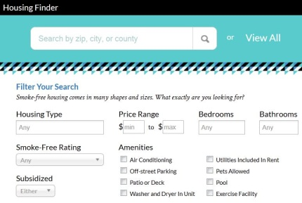
The Clear Gains Housing Finder is our statewide, online smoke-free housing finder and is found at www.wismokefreehousing.com/find.
Clear Gains Housing Finder

This is an excellent way for property owners and managers to publicize their smoke-free properties. Join over 70 properties listed as this continues to be promoted statewide!

If you choose to add your smoke-free property, you will be asked to create an account, which will include uploading your smoke-free policy or lease addendum. This is used to confirm that all properties listed on this site are smoke-free. Your policy will not be visible on the website.

One important way that we are able to track our impact in the state, is by collecting the smoke-free policies or lease addendums that are adopted. If you choose not to list your property on the Clear Gains Housing Finder, could you please forward your smoke-free policy or lease addendum language to Karen Doster at Karen.Doster@dhs.wisconsin.gov so we can include your properties in the statewide tracking? Your policy will not be shared or made public and is only used to ensure accurate tracking of the program.

Please do not hesitate to contact me if you have any questions. Again, I commend you for your desire to create healthier living environments.

Thank you,

[Name]
[Title]
[E-mail]
[Phone]

