New FDA Warning Labels Press Release Template

FOR IMMEDIATE RELEASE
March 17, 2019
CONTACT NAME AND INFO

FDA Unveils New Graphic Cigarette Warning Labels

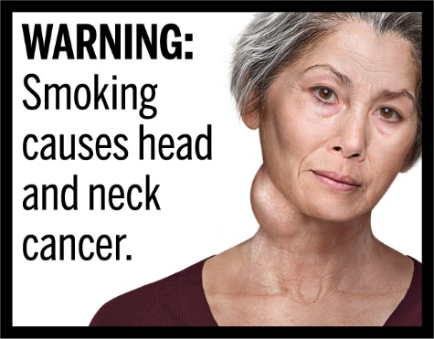
(CITY, WI) – The U.S. Federal Drug Administration (FDA) recently announced new graphic warning labels for cigarette packs and advertisements. The graphics cover a variety of health risks like lung disease, heart disease, head and neck cancer, stunted fetal growth, and type 2 diabetes. The warnings are required to appear on packs starting on June 18, 2021.

The new FDA rule specifies that the warnings must occupy the top 50% of cigarette packs and at least 20% of cigarette advertisements. The warnings must also be randomly and equally displayed on cigarette packages and rotated quarterly in cigarette ads.

“TALK ABOUT WHY THE NEW WARNING LABELS ARE A GOOD IDEA. SHARE THAT TEXT WARNINGS HAVE GOTTEN EASY FOR TOBACCO USERS TO AVOID AND DON’T HAVE THE SAME STOPPING POWER AS THESE WARNINGS. GIVE AN EXAMPLE OF ONE OF THE WARNINGS THAT YOU THINK IS ESPECIALLY IMPACTFUL,” said (CONTACT NAME) of (NETWORK/COALITION).

While e-cigarettes have received more media coverage over the last few years, cigarettes still take an enormous toll on Wisconsin. They remain the number one cause of preventable death in the state, and targeted advertising by the tobacco industry has resulted in some groups smoking at higher rates than the state average. (GIVE EXAMPLES OF DISPARITIES FROM https://www.dhs.wisconsin.gov/publications/p43073.pdf).

Graphic warnings are shown to be far more effective at communicating the health risks of smoking than text warnings (https://www.tobaccofreekids.org/assets/factsheets/0325.pdf). By implementing these new warnings, the U.S. not only follows best practice for preventing tobacco use and encouraging cessation, they also join over 120 other countries that have adopted similar warnings.

Current tobacco users that are ready to quit should call the Wisconsin Tobacco Quit Line at 1-800-QUIT NOW (784-8669) for free help and medications. Medicaid recipients who use tobacco are also encouraged to talk to their doctor about the free help available through the Medicaid Cessation Benefit.

For more information on local tobacco prevention and control efforts, please visit (COALITION/NETWORK URL, SOCIAL MEDIA, ETC.). You can also view the full collection of FDA’s cigarette warning labels at https://www.fda.gov/tobacco-products.

###

