COALITION/NETWORK TEMPLATE SOCIAL MEDIA PLAN

PRIMARY PLAN COMPONENTS
- PURPOSE: Describe what you hope to achieve through your social media efforts.
Examples: Increase awareness of tobacco’s burden; Raise awareness of coalition activities

- AUDIENCE(S): Describe who you want to reach with your efforts.
Examples: Adult Coalition Members, Legislators, Health and Public Health Professionals, Local Leaders, News Media

- POST FREQUENCY: Describe how often and during which times you plan to post. Think about when your audience is most likely to be on social media and plan accordingly.

- RELATIONSHIPS: Make a list of pages to follow, including commenting on and sharing their posts.
Questions to ask: What pages will help you increase your reach and are more popular among your followers? Who would also be willing to share your posts?

- GOALS/EVALUATION: How do you plan to measure success? Try to establish specific goals. Hone your strategy by paying attention to the types of posts your followers are responding to and plan accordingly since there’s no sense in continuing to post on topics that your followers aren’t interested in.
Example: By X date, followers will increase by X%

- ASSIGNING RESPONSIBILITY: Define who is responsible for posting, tracking, etc. to help ensure all tasks are completed.

- COMMENT POLICY: Being clear about the comments you will (and won’t) allow on your page may help you avoid issues down the road. The comment policy is usually placed in the “About” section of your page profile under “General Information”.
Example: COALITION/NETWORK NAME developed this Facebook page to encourage discussion on tobacco prevention and control issues. We encourage visitors to comment on our posts and engage in conversations to reduce tobacco’s burden. We expect all comments to be respectful and fair, and reserve the right to delete posts and comments that contain the elements listed below. COALITION/NETWORK NAME also reserves the right to block users that violate our comment policy.
  - Mean-spirited attacks against others
  - Vulgar or offensive language
  - Off-topic posts
  - Self-promotional marketing of your Facebook page or other commercial promotions
Thank you for respecting the policy. We look forward to engaging with you in productive discussions to improve Wisconsin’s health.

- CONTENT PLANNING: Try to plot out your content about a month ahead. This will eliminate a lot of guess work on your part.
Content Planning Suggestion: Establish content categories and assign them to different days in the month. Depending on the amount of advance time you have, you can either develop full posts up front or just fill in the content category for each day in advance and then write the full post at a later time. Try to leave a couple of calendar days open so you can react to tobacco news and current events.

ESTABLISHING CONTENT CATEGORIES
Here are some examples of content categories. Remember, these are just ideas. Feel free to think of your own categories or even better, ask your coalition members what they think you should be posting about. A content strategy should be developed for each of the coalition or network’s social media channels. This process should be repeated each month or you can block your content out by quarter.

- TN: Tobacco News
This could include items that receive major media coverage (CVS going tobacco-free, youth e-cigarette use tripling, e-cigarette regulation, etc.)
- SF: State Facts
Highlight tobacco usage stats for Wisconsin. One place you can pull from is the Fast Facts feature on the TPCP home page: https://www.dhs.wisconsin.gov/tobacco/index.htm.
- CN: Coalition News
Share a highlight from the coalition’s work, a picture of a coalition activity, environmental scans results, or a recent success. Tag coalition members to increase your reach.
- Throwback Thursday or Flashback Friday
There are lots of ways you can do this one. A photo from a smoke-free celebration party, classic tobacco industry ads, important dates in tobacco control (Master Settlement Agreement, Banning of tobacco ads on TV), etc.
- PQ: Poll Question
Engage your members by asking their opinion on an upcoming coalition activity, a controversial topic like legal tobacco sale age, or what kind of posts they’d like to see more of in the future. Poll questions aren’t recommended until you’ve already built up healthy engagement on your social media page.
- PS: Product Spotlight
Highlight outrageous tobacco or nicotine products. This is a good way to demonstrate the need for continued work. Things to focus on might be kid-tempting flavors, price, etc.
- PC: Pop Culture or General News
It can be good to show a human side. Perhaps talk about upcoming events, movies, things in the news, sporting events. Use sparingly.
- RT: Related Topics
Highlight the work of a public health partner or topic (nutrition and physical activity, AODA, mental illness, etc.)
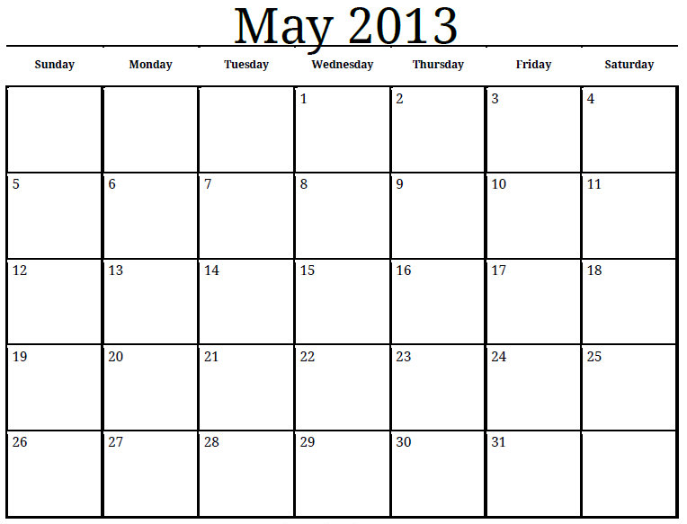
CN Throwback TN RT

RT PS Flashback SF

PQ Throwback PC PS

RT PS Flashback Open

CN Throwback SF

PC PS TN

CN TN RT

SF CN TN

PC SF PQ
EXAMPLE FACEBOOK CONTENT CALENDAR FOR A MONTH

